PROJECT TITLE: Accident Detection System

The domain of the Project:

AIML

Team Mentors (and their designation):

Gaurav Patel (Data Engineer at Celebal Technologies)

Team Members:
Mr. Ved Devanand Dhanokar

Period of the project

April 2026 to Jun 2026

Declaration
The project titled “Accident Detection System: Real-Time AI-Based Accident Detection Using Computer Vision” has been mentored by Gaurav Patel, organised by SURE Trust, from April 2026 to June 2026, for the benefit of the educated unemployed rural youth for gaining hands-on experience in working on industry-relevant projects that would take them closer to prospective employers. I declare that, to the best of my knowledge, the members of the team mentioned below have worked on it successfully and enhanced their practical knowledge in the domain.

Team Members:
Mr. Ved Devanand Dhanokar
Signature: 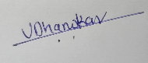

Mentor’s Name : Mentor’s Name
Designation—Company Name : Gaurav Patel Designation— Celebal Technologies

Prof. Radhakumari
Executive Director & Founder
SURE Trust

Table of contents
- Executive summary
- Introduction
- Project Objectives
- Methodology & Results
- Social / Industry relevance of the project
- Learning & Reflection
- Future Scope & Conclusion

Executive Summary
Road accidents remain one of the leading causes of fatalities worldwide, with delayed detection and emergency response significantly increasing the severity of injuries and loss of life. Many existing surveillance systems rely on manual monitoring, making it difficult to identify accidents in real time, especially in areas with limited human supervision. To address this challenge, this project presents an AI-Based Accident Detection System that automatically detects road accidents from video footage using advanced computer vision and deep learning techniques.
The primary objective of this project is to develop an intelligent and automated system capable of monitoring road traffic, detecting vehicle collisions accurately, and providing timely alerts to facilitate faster emergency response. The proposed system processes video streams and analyzes vehicle movements to identify abnormal driving behavior and collision events without requiring continuous human intervention.
The system follows a multi-stage processing pipeline. Initially, video frames are extracted using OpenCV. YOLOv8 is employed to detect vehicles present in each frame with high accuracy and speed. The detected vehicles are then tracked across consecutive frames using ByteTrack, enabling the system to maintain consistent identities for each vehicle throughout the video. After tracking, ResNet18 extracts deep visual features from the vehicle images, capturing essential information related to vehicle appearance and collision characteristics. These feature vectors are passed to a Long Short-Term Memory (LSTM) network, which analyzes temporal patterns across multiple frames to understand vehicle motion and predict the likelihood of an accident.
In addition to visual features, the system computes several telemetry-based parameters, including vehicle speed, acceleration, jerk, Time-to-Collision (TTC), and optical flow. These parameters provide valuable information about vehicle dynamics and help distinguish genuine accidents from normal traffic behavior. The outputs from the LSTM model and telemetry calculations are combined using a Multi-Layer Perceptron (MLP), which produces the final accident confidence score. A Markov Decision Process (MDP) is then used to manage the system's operational states, ensuring stable decision-making and preventing repeated or false accident alerts by transitioning between states such as Normal, Risk, Collision, Post-Impact, and Recovery.
To improve situational awareness, the system integrates DigiLocation, which associates accident events with location information. The detected accident details, confidence score, and location are transmitted through a WebSocket connection and displayed on a React-based dashboard, enabling real-time visualization and monitoring.
The project was developed using Python as the primary programming language, along with PyTorch for deep learning, OpenCV for image processing, YOLOv8 for object detection, ByteTrack for object tracking, React for the user interface, Node.js for backend communication, and SQLite for data storage.
Experimental evaluation demonstrates that combining deep learning with telemetry analysis improves accident detection reliability compared to approaches relying solely on visual information. The integration of multiple AI models enables the system to analyze both spatial and temporal characteristics of vehicle movement, thereby reducing false alarms and improving overall detection performance.
Although the current implementation operates as a prototype and is not deployed in a real-world environment, it successfully demonstrates the feasibility of intelligent accident detection using artificial intelligence. The system has the potential to assist traffic monitoring authorities, smart city initiatives, highway surveillance systems, and emergency response services by reducing accident detection time and enabling quicker assistance.
Future enhancements include deploying the system on edge devices, integrating automatic emergency notification services, improving performance under adverse weather and nighttime conditions, expanding support for multi-camera surveillance, and incorporating GPS-enabled live location sharing for faster emergency response.
Overall, this project demonstrates the practical application of artificial intelligence, computer vision, and deep learning in addressing a critical real-world problem. It provides a scalable foundation for developing intelligent traffic safety solutions that contribute to reducing accident response time and improving road safety.

Introduction
1.1 Background and Context of the Project
Road accidents are one of the leading causes of injuries and fatalities worldwide. Delayed accident detection often results in slower emergency response, increasing the severity of accidents. Traditional traffic monitoring systems rely heavily on manual observation, which is time-consuming and prone to human error.
With advancements in Artificial Intelligence (AI) and Computer Vision, it is now possible to automatically analyze traffic videos and detect accidents in real time. This project presents an AI-Based Accident Detection System that uses deep learning and computer vision techniques to identify road accidents from video footage and display the detected incidents on a real-time dashboard.

1.2 Problem Statement
Manual monitoring of traffic cameras is inefficient for detecting accidents quickly. Existing automated systems may generate false alarms because they rely only on visual information. The goal of this project is to develop an intelligent system that combines visual analysis and vehicle telemetry to accurately detect road accidents while minimizing false detections.

1.3 Scope of the Project
The project focuses on developing a prototype for automatic accident detection using AI. It includes:
- Vehicle detection using YOLOv8
- Vehicle tracking using ByteTrack
- Feature extraction using ResNet18
- Temporal analysis using LSTM
- Telemetry calculations such as speed, acceleration, jerk, Time-to-Collision (TTC), and optical flow
- Decision making using MLP and MDP
- Real-time monitoring through a React dashboard with DigiLocation integration

1.4 Limitations of the Project
The current system is a prototype and has not been deployed in a real-world environment. Its performance may be affected by poor lighting, adverse weather conditions, low-resolution videos, and heavy traffic. It currently processes a single video stream and focuses primarily on vehicle collision detection.

1.5 Innovation Component
The key innovation of this project is the integration of multiple AI techniques into a single accident detection framework. Unlike systems that rely only on object detection, this solution combines YOLOv8, ByteTrack, ResNet18, LSTM, telemetry analysis, MLP, and MDP to improve detection accuracy and reduce false alerts. The addition of DigiLocation and a real-time dashboard further enhances accident monitoring and reporting.

Project Objectives
2.1 Objectives
The primary objectives of the AI-Based Accident Detection System are:
- To develop an intelligent system for automatic detection of road accidents using Artificial Intelligence and Computer Vision.
- To accurately detect and track vehicles in video streams using YOLOv8 and ByteTrack.
- To analyze vehicle movement over time using ResNet18 and LSTM for reliable accident prediction.
- To calculate telemetry parameters such as speed, acceleration, jerk, Time-to-Collision (TTC), and optical flow to improve detection accuracy.
- To reduce false accident alerts through MLP-based decision fusion and MDP-based state management.
- To display detected accidents and their locations on a real-time React dashboard with DigiLocation integration.
- To demonstrate the practical application of AI in enhancing road safety and supporting faster emergency response.

2.2 Expected Outcomes and Deliverables
Expected Outcomes
- An AI-powered system capable of automatically detecting road accidents from video footage.
- Improved accident detection reliability through the combination of visual and telemetry-based analysis.
- Real-time monitoring of accident events with location information.
- A prototype that demonstrates the feasibility of intelligent traffic surveillance using deep learning.
Deliverables
- AI-Based Accident Detection System prototype.
- Vehicle detection and tracking module.
- Accident detection and decision-making module.
- React-based real-time monitoring dashboard.
- Project source code and documentation.
- Final project report and presentation.
This version is concise, professional, and aligns well with the format typically used in SURE Trust project reports.

Methodology and Results
3.1 Methods / Technologies Used
The proposed AI-Based Accident Detection System uses Artificial Intelligence and Computer Vision to automatically detect road accidents from video footage. The system processes video frames through multiple stages to identify accidents accurately while reducing false alerts.
The methodology includes:
- OpenCV for frame extraction.
- YOLOv8 for vehicle detection.
- ByteTrack for vehicle tracking.
- ResNet18 for feature extraction.
- LSTM for temporal analysis.
- Telemetry Analysis (speed, acceleration, jerk, TTC, and optical flow).
- MLP for accident confidence prediction.
- MDP for state management and false alert reduction.
- DigiLocation integration and a React Dashboard for real-time monitoring.

3.2 Tools / Software Used
Tool | Purpose
Python | Programming Language
OpenCV | Frame Processing
YOLOv8 | Vehicle Detection
ByteTrack | Vehicle Tracking
PyTorch | Deep Learning
React.js | Dashboard
Node.js | Backend
SQLite | Database
Git & GitHub | Version Control

3.3 Data Collection Approach
The system uses road traffic video datasets containing normal driving and accident scenarios. Video frames are processed to extract vehicle movements and telemetry parameters, which are used by deep learning models to detect accidents.

3.4 Project Architecture
The system follows a multi-stage architecture for accident detection.
Architecture Explanation
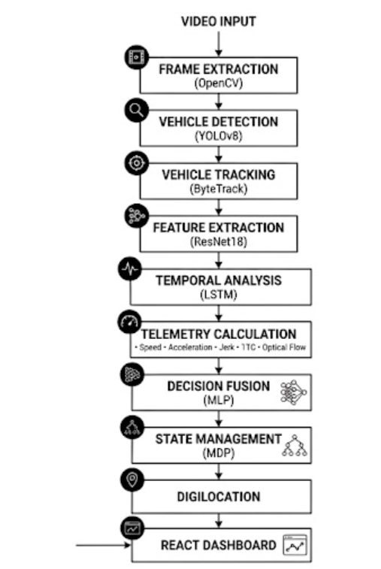
The system extracts video frames using OpenCV and detects vehicles with YOLOv8. ByteTrack maintains vehicle identities across frames, while ResNet18 and LSTM analyze visual and temporal features. Telemetry parameters are combined with deep learning outputs using an MLP to determine accident confidence. Finally, the MDP manages accident states, and the results are displayed on the React dashboard along with DigiLocation information.

3.5 Project GitHub Link
GitHub Repository:
      - https://github.com/sure-trust/VED-DEVANAND-DHANOKAR-g37-ai-ml/tree/main/Final%20capstone%20project/accident_detection

      - https://github.com/Ved2151H/accident_detection_System

Learning and Reflection
4.1 Learning
During the development of this project, I gained practical knowledge of Artificial Intelligence, Computer Vision, and Deep Learning by implementing a real-world accident detection system. I learned how to use OpenCV for video processing, YOLOv8 for vehicle detection, ByteTrack for object tracking, ResNet18 for feature extraction, and LSTM for temporal sequence analysis. I also understood the importance of telemetry parameters such as speed, acceleration, jerk, Time-to-Collision (TTC), and optical flow in improving accident detection accuracy.
Apart from technical skills, I improved my understanding of software development practices, including code organization, debugging, version control using Git and GitHub, and integrating backend services with a React-based dashboard. This project enhanced both my technical and problem-solving abilities.

4.2 Reflection
Working on this project was a valuable learning experience that strengthened my ability to apply theoretical concepts to a real-world problem. Throughout the project, I faced challenges such as integrating multiple AI models, handling video data efficiently, and reducing false accident detections. Overcoming these challenges improved my analytical thinking, patience, and debugging skills.
The project also helped me develop better project planning, time management, and documentation skills. Overall, this experience increased my confidence in building AI-based applications and motivated me to continue exploring intelligent systems that can contribute to solving real-world challenges.

Conclusion and Future Scope
5.1 Conclusion
The AI-Based Accident Detection System successfully demonstrates the use of Artificial Intelligence and Computer Vision for automatic road accident detection. The project achieved its primary objective of detecting and tracking vehicles, analyzing their movement, and identifying accident events using a combination of YOLOv8, ByteTrack, ResNet18, LSTM, telemetry analysis, MLP, and MDP. The integration of DigiLocation and a React dashboard enables real-time monitoring of detected accidents. Overall, the project provides a reliable prototype that highlights the potential of AI in improving road safety and reducing accident response time.

5.2 Future Scope
The proposed system can be further enhanced in several ways:
- Deploy the system for real-time traffic surveillance using live CCTV feeds.
- Improve detection performance under low-light and adverse weather conditions.
- Extend the system to support multiple camera feeds simultaneously.
- Integrate automatic emergency notification services for faster response.
- Expand the system to detect additional traffic incidents, such as pedestrian accidents and vehicle breakdowns.
- Optimize the models for deployment on edge devices and smart city infrastructure.

